Name:  Teacher : | ____________________________________  ______________________ |  | Date:_________
 | Year 12 Foundation  /36  Task 4: Test 2  Full working out MUST be shown to get full marks for each question.
Total Time: | 40 minutes
Weighting: | 7%
Equipment: | To be provided by the student: Pen, pencil, ruler, scientific calculator, INB

Question 1

Map of the Central Business District of Melbourne.

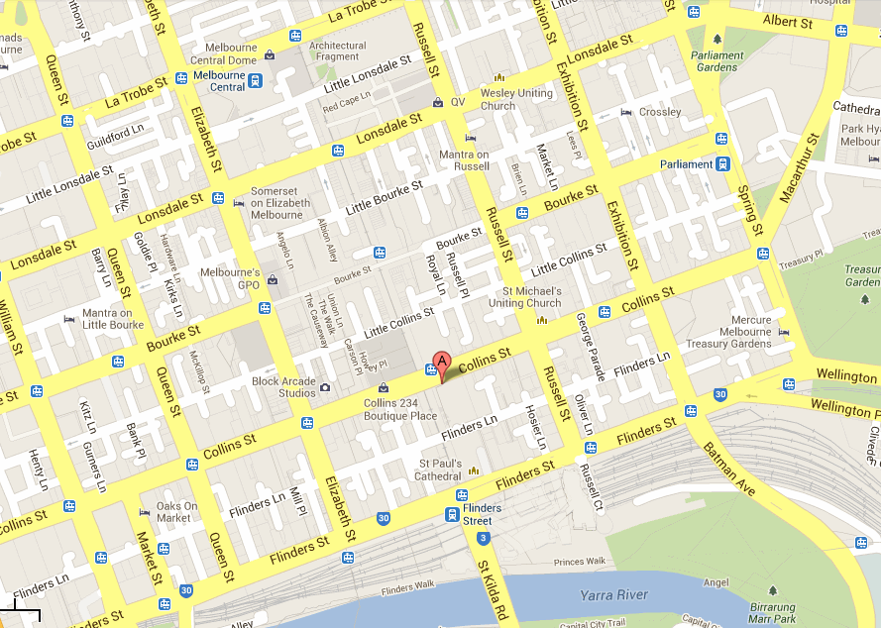
B

Scale 1 : 20 000 (1 cm = 200 m)

Question 1.

7 marks (2, 2, 3)

You are on holidays with a friend in Melbourne and decide to walk around the city of Melbourne. You are located at (A) on Collins Street.
(a) | Describe in words how you would walk to Parliament Gardens on Albert Street.
(b) | Using the given scale how far is it to walk to Flinders Street Station opposite St Paul’s Cathedral from the corner of Queens Street and Flinders street?
(c) | You wish to walk to the Mercure Melbourne Treasury Gardens (B), walking along Collins Street. If you are walking at a speed of 100 metres per minute, how long would it take you to walk the distance?  Question 2  5 marks (1, 1, 2, 1)  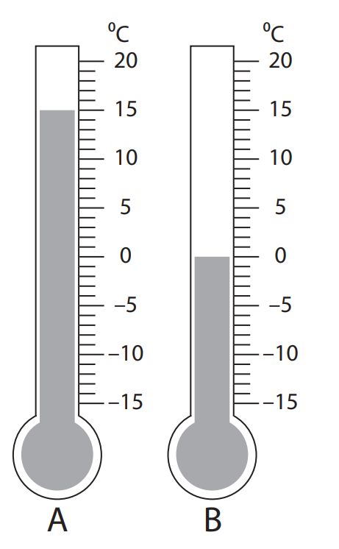  - What is the maximum temperature?  - What is the minimum temperature?  - What is the range of the temperatures?  - What season do you think this would be if these were Perth temperatures?

Question 3

10 marks (2, 2, 2, 2, 1, 1)
 | How many hours and minutes between:
(a) | 10:00 a.m. and 6:00 p.m.? | (b) |  |  | 8:35 a.m. and 5:15 p.m.?
 | Write each of the following times using both 12-hour and 24-hour time:
(c) | 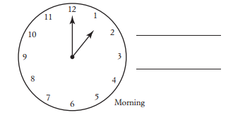 |  |  |  |  | (d) |  | 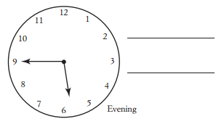
 | Write each of the following in 12-hour time, using numbers:
(e) | ‘twenty-five minutes after one’ in the morning |  |  |  | (f) |  |  | ‘ten minutes before three’ in the daytime

Question 4

6 marks (2, 2, 2)
 | 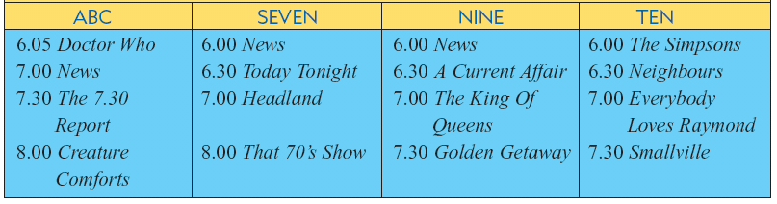
(a) | At what time do the following programs begin |  |  | (b) |  |  | How long are each of the following programs?
(i) | Neighbours |  |  | (i) |  |  | Doctor Who
(ii) | Creature Comforts |  |  | (ii) |  |  | The Simpsons
(c) | If you just finished watching Doctor Who, how long do you need to wait to see that 70’s Show?

Question 5
8 marks ( 2, 1, 1, 2, 2)
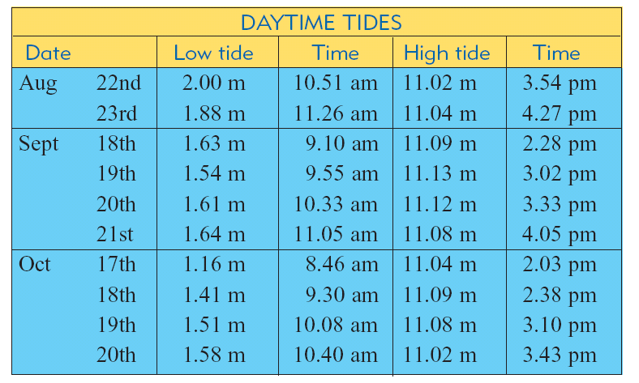
The table below gives the heights and times of high and low tides for several days over 3-month period.

(a) | On 19th September what is the height of the high tide and when does it occur?
(b) | On 18th September:
(i) | When do the low and high tide occur? |  | (ii) |  |  | What is the time difference between the low and the high tide?
(c) | Emily believes that it is best to go fishing half an hour after a high tide. If this is true what would be the best time to go fishing on October the 18th ?  END OF TEST

